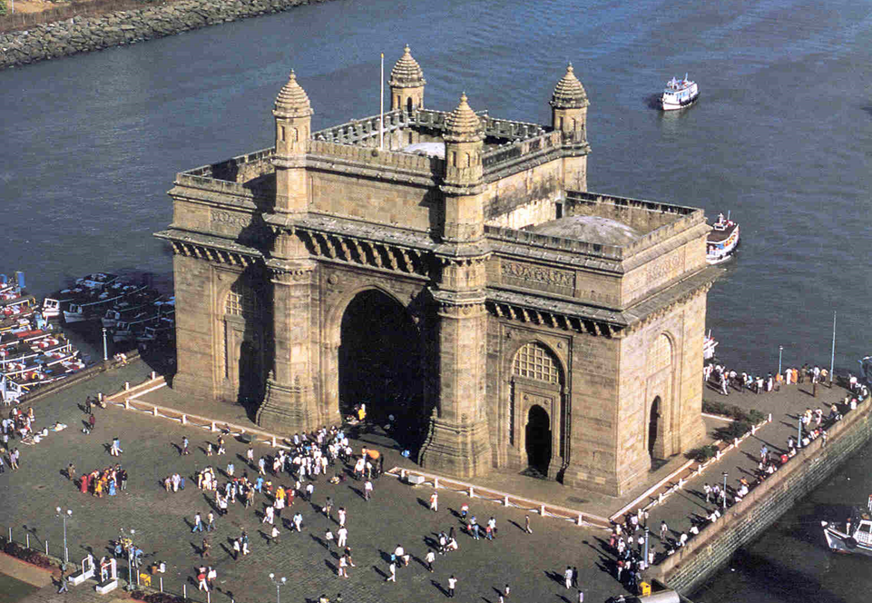

**03 Nights / 04 Days Mumbai Extension**

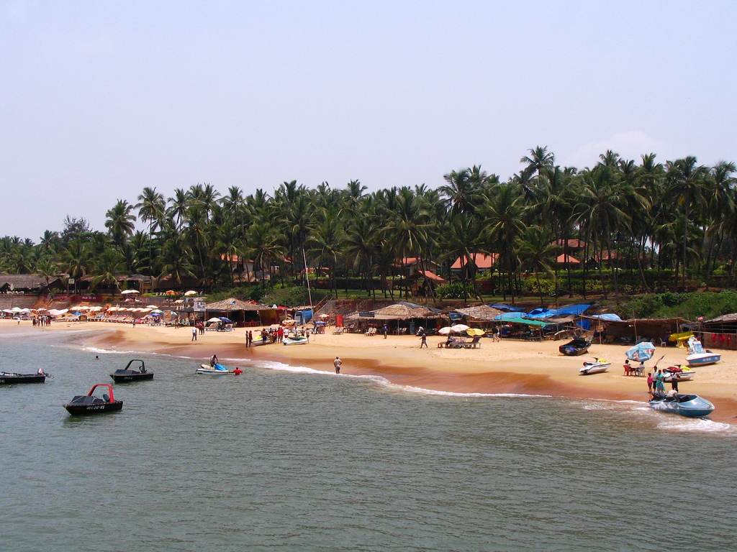

**Day 01 ARRIVE MUMBAI ex Jaipur by flight**

Arrive Mumbai . Upon arrival you will be met by dnata representative & transfer to Hotel.

**Mumbai (formerly Bombay**), situated on the western coast of India, is the city of glamour and megastars, of industrialists and business houses, of a futuristic lifestyle and an amalgamation of the West with the traditional Maharashtrian culture. Apart from being the financial capital of India, it is also the capital of India's most progressive state, Maharashtra. Mumbai is the gateway of India, the point of arrival for most of the visitors who travel to Mumbai on business or holiday. Today Mumbai stands tall as India's commercial capital and the country's most cosmopolitan city.

Check-in at hotel and stay for 2 nights.

**Meals included: None**

**Overnight at hotel**

**Day 2 IN MUMBAI**

Morning post breakfast excursion to Elephanta caves. (Closed on Monday & monsoon)

An hour's boat ride from the Gateway, the tranquil forested island of Elephanta is one of the most atmospheric places in Bombay. Populated only by a small fishing community it makes a wonderful contrast to the seething claustrophobia of the city, even when crowded with day trippers at weekends. Originally known as Gharapuri, the island was renamed in the sixteenth century by the Portuguese in honor of the carved elephant they found at the port. Its chief attraction is the unique cave temple whose massive Trimurti Shiva sculpture is a fine example of Hindu architecture. The cave temples were excavated between the 5th and 8th centuries. The island is just an hour away by motor launch and the caves are reached by a stairway up the hillside from the ferry landing.

Afternoon proceed for half day city tour of Mumbai.

Start with a stop at the Gateway of India –a Indo – Sarcenic style of architecture (1927), designed by George Wittet to commemorate the visit of George V and Queen Mary in 1911, drive, past the Victoria Terminus the most remarkable example of Victorian Gothic architecture in India opened during Queen Victoria’s Golden Jubilee Year, Marine Drive and visit the Hanging Gardens so named since they are located on top of a series of tanks that supply water to Bombay. Visit the Jain Temple built of marble and dedicated to the first Jain Tirthankaras. Much of the decoration depicts the lives of the Tirthankaras. And last but not the least; make a brief photo stop at “Dhobi Ghat” the Indian laundry system.

Later visit Prince of Wales Museum. A magnificent, but somewhat strange structure, built in a confluence of Gothic and Moorish styles, and crowned by a sparkling white dome.

Afternoon at leisure.

**Meals included: Breakfast**

**Overnight at hotel**

**Day 03 IN MUMBAI**

Day free at leisure for independent activities OR clients can choose any of the following optional tours enclosed in pdf. ( Prices given separately )

**Meals included: Breakfast**

**Overnight at hotel**

**Day 04 LEAVE MUMBAI**

**In time transfer to airport to connect flight for onward destination.**